Design Links:<https://www.figma.com/file/dflaGXC6EfwEYhufOlxtHQ/LeapifyTalk?node-id=1%3A8>

Testing Url:<https://musing-saha-2d39c9.netlify.app/>

Goal:

User experience testing is the process of testing different aspects of user experience to determine the best way for a website and its elements to interact with its audience

Instruction:

* Go through the above design link. Understand the scope of the website.
* You have to create a UI/UX testing report. Find as many bugs as possible in terms of fount, text navigation, and icons etc.
* Record a 2 min video with audio explaining few UX bugs.

Below is examples -



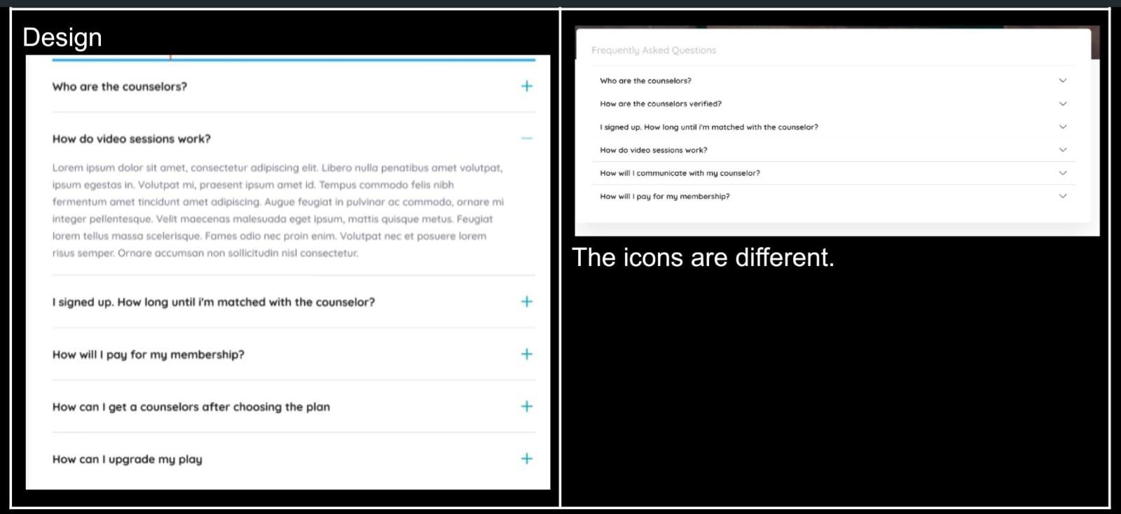

Note:

1. Make a report on above format

2. Find as many UI/UX bugs as possible.. More you find, the better chances of getting shortlisted.

3. This task should be performed on IOS only.